**Experiment 7: Creating and Managing a User Story in Jira**

**🔷 Aim:**

To learn how to create a User Story in Jira, assign it to a team member, and manage its progress through the Scrum workflow (TO DO → IN PROGRESS → DONE).

**🔷 Objective:**

* Understand how to create and define a User Story in a software project.
* Learn the use of Jira for tracking tasks and user stories visually.
* Learn about various issue fields like Assignee, Labels, Due Date, Sprint, etc.

**🔷 Software/Tool Used:**

* **Jira** (Free/Trial version)
* Sample Project: **Gardencity University**

**🔷 Procedure:**

**Step 1: Login and Open Project**

* Login to your **Jira account** at https://www.atlassian.com/software/jira
* Go to your project dashboard (e.g., **Gardencity University**)

**Step 2: Create a New Story**

1. Click the **“Create”** button on the top navigation bar.
2. Fill in the following fields in the popup window:

**📝 Detailed Field Explanation (during Story Creation)**

| **Field Name** | **Explanation** | **Example** |
| --- | --- | --- |
| **Project** | Select your working project. | Gardencity University |
| **Issue Type** | Select **Story** to represent a feature or user need. | Story |
| **Summary** | Short title or name of the story. | Design Login Page |
| **Description** | Detailed explanation of what the story is about. Can include requirements, UI mockups, etc. | UI must include email, password, remember me |
| **Assignee** | The person who will work on this story. | Select your name or a teammate |
| **Reporter** | The person who created/reported this issue. (Auto-filled) | Your name |
| **Labels** | Tags to group or filter stories later. Useful for search. | login-ui, frontend |
| **Priority** | Level of importance: Low, Medium, High, Critical. | High |
| **Epic Link** | Link this Story to a bigger Epic if applicable. | User Account Features (optional) |
| **Sprint** | Add this story to a specific sprint. (Scrum teams only) | Sprint 1 |
| **Story Points** | Used to estimate effort. Scrum teams usually use 1–8 points. | 3 Story Points |
| **Start Date** | Date when work starts. | e.g., 26-May-2025 |
| **Due Date** | Deadline to complete the work. | e.g., 28-May-2025 |
| **Parent** | Optional. Use if this story is part of a larger Task. | Not required unless sub-task |
| **Team** | Team working on the story. Useful for large orgs. | UI Team (optional) |

**Screen shot:**

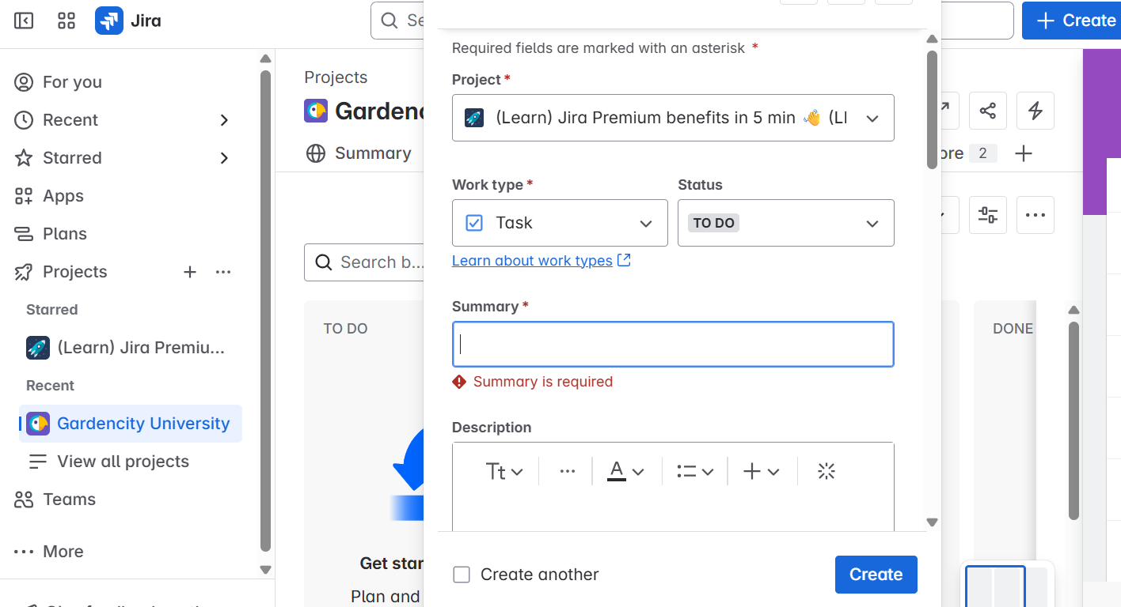

**Step 3: Submit the Story**

* After filling the above fields, click **Create**.

**Step 4: Track the Story on the Board**

1. Go to the **Board** (top navigation menu).
2. The newly created story will appear under **TO DO**.
3. Drag it to **IN PROGRESS** once work starts.
4. Move it to **DONE** once completed and verified.

**🔷 Result:**

A user story was successfully created in Jira with full detail, assigned to a team member, added to a sprint, and tracked through the Scrum board.